USER MANUAL

Section 1: Information about SuperQuote

Section 2: The Registration Process

Section 3: Creating a Request for Quotation

Section 4: Creating a Request for Information

Section 5: Creating a Request for Proposal

Section 6: The Status Codes

Section 7: Lost or Forgotten Passwords

Section 8: Bids Via email

Section 9: Getting a Draft From the Draft Folder

Section 10: The Difference between Draft and Active

Section 11: The History Folder

Section 12: Canceling, Addendum or Copying a Request

Section 13: Categories not in the Category List

Section 14: Checking on Quotes and Selecting a Winning Vendor

Section 15: Checking the Status of the Winner Vendor

Section 16: The Vendor accepted the Award, what now?

Section 17: The Vendor Declined the Award

Section 18: Awarded the Wrong Vendor and how to fix

Section 19: Viewing a Request your Secretary Submitted

Section 20: Changing the Requisitioner Information

Section 21: Changing the Information on your Profile

Section 22: Using the Vendor Directory

Section 23: Viewing Group Requests and Group Activities

Section 24: Viewing of the Selected Bid

Section 25: Frequently Asked Questions (FAQ)

Section 1: Information about SuperQuote
SuperQuote™ is an open, web-based platform based on the widely used RFQ (Request for Quotation), RFI (Request for Information), and RFP (Request for Proposal) methodology. This flexible system allows buyers to create requests by filling out an electronic form. Once the form is submitted, vendors are able to reply with price quotes and product information online without using any of the manual process that was required before.
Section 2: The Registration Process
Step 1: Go to www.CommercePoint.com. Then click on "UH Buyers" or the UH Logo.

Click This Link to Register
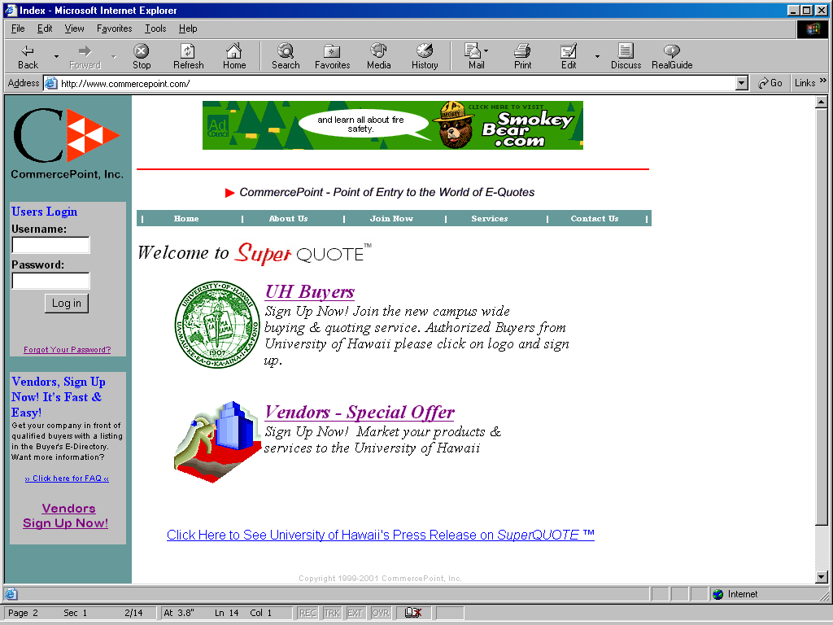
Top of Form
Bottom of Form

Step 2: Enter your campus password.
Step 3: Select your organization. Buyers from the University of Hawaii will select "University of Hawaii," as your organization. Buyers from the City and County of Honolulu will select "City & County of Honolulu".
Step 4: Select your School or Department as your group. Then click "Join" when the page is done loading.
Step 5: Select your position (most would pick General Buyer). If you are not sure consult your Supervisor.
Step 6: Select a Supervisor. This means that your supervisor must register before you can register. If your position is Procurement Chief, you do not need to select a Supervisor.
Step 7: Click on "Select this Position and Supervisor."
Step 8: Enter your Contact Information and Company Information. For "Ship Via," enter your preference of how you want the items shipped, such as "UPS," "Federal Express" or "Best Way." For shipping information, enter an address only if your company address is different from the address of which you want the items shipped to
Step 9: Enter your login name and password. Confirm what your password is. You will also need to select a password question and answer the question. This is just in case you forgot your password. If you forget your password please read the section on forgotten passwords. When you have completed all the blanks, click "Submit." Please Note: when logging in to SuperQuote™, the user names and passwords are case sensitive. For example: If your user name is "JohnDoe" you cannot type "johndoe" or "JoHnDoE".
Section 3: Creating a Request for Quotation (RFQ)
Step 1: First login using your user name and password.
Step 2: Click on "Create a New Request." This is located in the upper left of the page. Some information has been provided from the Buyer Sign Up Screen. You can change this information by typing over it or you can update your profile by clicking on Update Profile to change the information you have on file.
Step 3: Make sure the following has been completed:
· Make sure the Request Type is "Request for Quotation" (RFQ).
· Select an Open and Close Date and Time.
· Type in a Subject (a title for your request). For example: "Office Supplies" or "Laser Printers" would be a subject.
· Select a Category that best defines the item(s) on your request. For example: "Computer Software". Try and pick a category that has the closest match to your request. If you are creating a request that contains a PC, some software and some print supplies, you can pick the "Computer Hardware" category as the closest match. If you have items that would not be in the same Category, you will have to do a separate RFQ. If you do not find such a Category that matches your requirement, please feel free to email support@commercepoint.com or email your supervisor.
· Type in any Special Instructions to the vendors. Use this section to qualify the vendor. For example: Local Service and support is required or must be an authorized Sony Dealer. Also, include any information about time information, such as dates the item(s) must be received by.
· Date Required is the date the items must be delivered by. Use the "Clear" button if you wish to leave the date blank and type in details in the Special Instructions area. For example: Delivery required 5 days after P.O has been issued.
· It is possible to attach files created on your hard drive to a RFQ. Click on "Attached Files" and then locate the file on your hard drive. Such things that you might want to use an attached file for is to explain long specifications, special terms and conditions or a graphic file.
· Type in a number amount for the quantity of items you need under "Quantity".
· For "Item Description" Type in a brief description of the items such as: Brand name, model #, color or size.
· Click on "Add More Items" if you have more than 5 items on your list. The first 5 spaces must be used before you use this.
· Type in any "Notes" to yourself or to the vendors that are either "private" (for your view only) or "public" (for all vendors to view). Use "private" notes to track communications with supervisors or use "public" to clear up any specific requests with the vendors.
Step 4: Select from the five options at the bottom of the screen:
· "Save as Draft" saves your RFQ as a draft.
· "Submit Request" submits the request (see step 5).
· "Print Request" prints the request.
· "Reset" will delete all the information you typed in.
· "Email Request" emails your request to a fiscal officer or manager. To email to multiple people use a ";" to separate multiple email addresses.
Step 5: Submitting a request:
· Click on the "Submit Request" button. This will ask you "Are you sure you want to submit?"
· Click on "OK."
· Next you will be prompted "Would you like to print?" If you want to print click "OK". If you do not want to print click "Cancel".
· Your request is now an OPEN request for vendors to view and submit quotations on.
Here are several images that will also help, as they show exactly where to click and the location of the exact fields.

Click Here to Create a new Request
Click Here to view Your Requests This Shows the Status of your Bids
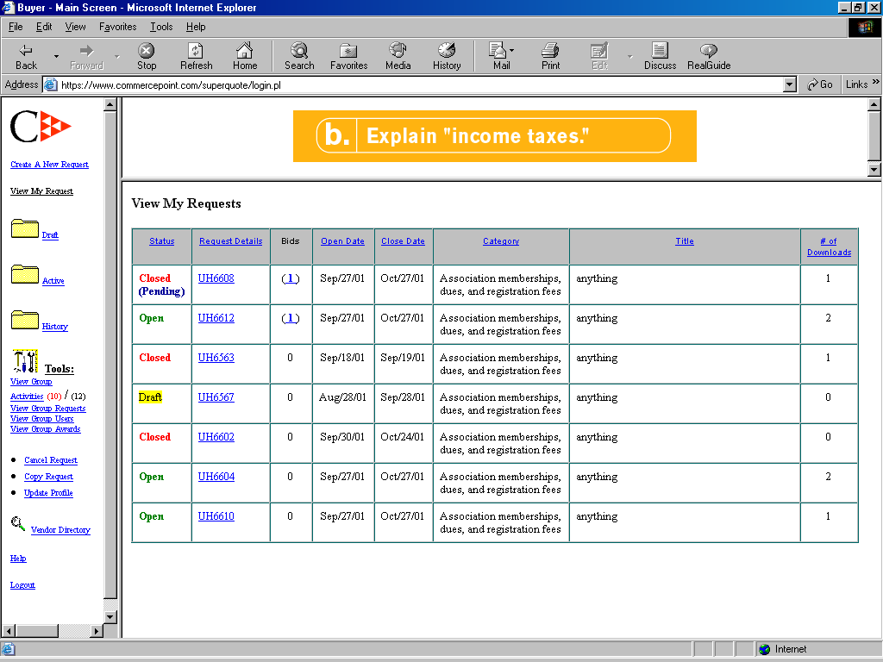

Choose type of Request Enter Open and Close date
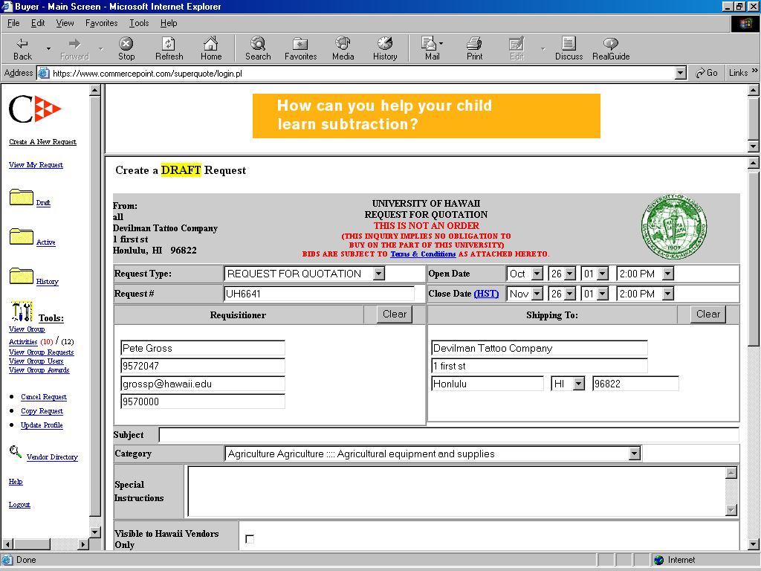

This is the Shipping information, change it if you wish Put in a title for your Request

Choose a Category
Fill in any special instructions you may have
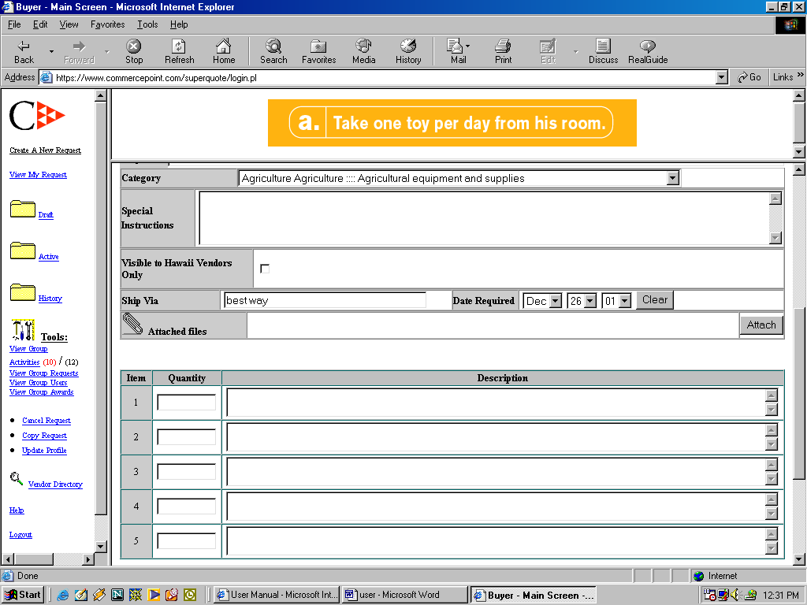
Choose the shipping method Attach a file by clicking here
Date merchandise must be received by

Enter in a numerical value of amount of items Enter a description of the items
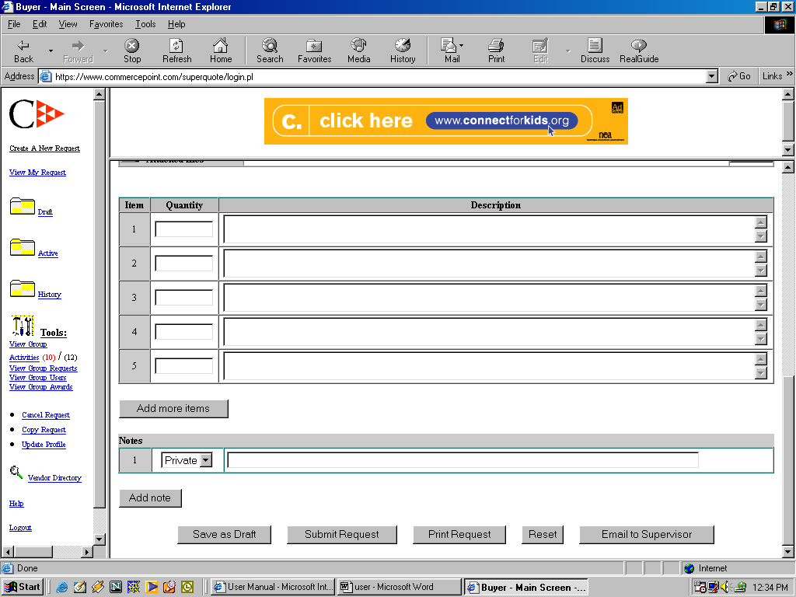
Add a note by clicking here Type note info here
If more then 5 items are being requested click here to add more

Click Here to save to draft folder Click here to print Click here to email form
Click here to submit Click here to clear form

Section 4: Creating a Request for Information (RFI)
Step 1: First login using your user name and password.
Step 2: Click on "Create a New Request." This is located in the upper left of the page. Some information has been provided from the Buyer Sign Up Screen. You can change this information by typing over it or you can update your profile by clicking on Update Profile to change the information you have on file.
Step 3: Make sure the following has been completed:
· Make sure the Request Type is changed to "Request for Information" (RFI).
· Select an Open and Close Date and Time.
· Type in a Subject (a title for your request). For example: "Office Supplies" or "Laser Printers" would be a subject.
· Select a Category that best defines the item(s) on your request. For example: "Computer Software". Try and pick a category that has the closest match to your request. If you are creating a request that contains a PC, some software and some print supplies, you can pick the "Computer Hardware" category as the closest match. If you have items that would not be in the same Category, you will have to do a separate RFI. If you do not find such a Category that matches your requirement, please feel free to email support@commercepoint.com or email your supervisor.
· Type in any Special Instructions to the vendors. Use this section to qualify the vendor. For example: Local Service and support is required or must be an authorized Sony Dealer. Also, include any information about time information, such as dates the item(s) must be received by.
· It is possible to attach files created on your hard drive to a RFI. Click on "Attached Files" and then locate the file on your hard drive. Such things that you might want to use an attached file for is to explain long specifications, special terms and conditions or a graphic file.
· Type in a number amount for the quantity of items you need under "Quantity".
· For "Item Description" Type in a brief description of the items such as : Brand name, model #, color or size.
· Click on "Add More Items" if you have more than 5 items on your list. The first 5 spaces must be used before you use this.
· Type in any "Notes" to yourself or to the vendors that are either "private" (for your view only) or "public" (for all vendors to view). Use "private" notes to track communications with supervisors or use "public" to clear up any specific requests with the vendors.
Step 4: Select from the five options at the bottom of the screen:
· "Save as Draft" saves your RFI as a draft.
· "Submit Request" submits the request (see step 5).
· "Print Request" prints the request.
· "Reset" will delete all the information you typed in.
· "Email Request" emails your request to a fiscal officer or manager. To email to multiple people use a ";" to separate multiple email addresses.
Step 5: Submitting a request:
· Click on the "Submit Request" button. This will ask you "Are you sure you want to submit?"
· Click on "OK."
· Next you will be prompted "Would you like to print?" If you want to print click "OK". If you do not want to print click "Cancel".
· Your request is now an OPEN request for vendors to view and submit quotations on.
Here are several images that will also help, as they show exactly where to click and the location of the exact fields.

Click Here to Create a new Request
Click Here to view Your Requests This Shows the Status of your Bids

Choose type of Request Enter Open and Close date

This is the Shipping information, change it if you wish Put in a title for your Request

Choose a Category
Fill in any special instructions you may have
Choose the shipping method Attach a file by clicking here
Date merchandise must be received by

Enter in a numerical value of amount of items Enter a description of the items
Add a note by clicking here Type note info here
If more then 5 items are being requested click here to add more

Click Here to save to draft folder Click here to print Click here to email form
Click here to submit Click here to clear form

Top of Form
Bottom of Form
Section 5: Creating a Request for Proposal
Step 1: First login using your user name and password.
Step 2: Click on "Create a New Request." This is located in the upper left of the page. Some information has been provided from the Buyer Sign Up Screen. You can change this information by typing over it or you can update your profile by clicking on Update Profile to change the information you have on file.
Step 3: Make sure the following has been completed:
· Make sure the Request Type is changed to "Request for Proposal" (RFP).
· Select an Open and Close Date and Time.
· Type in a Subject (a title for your request). For example: "Office Supplies" or "Laser Printers" would be a subject.
· Select a Category that best defines the item(s) on your request. For example: "Computer Software". Try and pick a category that has the closest match to your request. If you are creating a request that contains a PC, some software and some print supplies, you can pick the "Computer Hardware" category as the closest match. If you have items that would not be in the same Category, you will have to do a separate RFP. If you do not find such a Category that matches your requirement, please feel free to email support@commercepoint.com or email your supervisor.
· Type in any Special Instructions to the vendors. Use this section to qualify the vendor. For example: Local Service and support is required or must be an authorized Sony Dealer. Also, include any information about time information, such as dates the item(s) must be received by.
· It is possible to attach files created on your hard drive to a RFP. Click on "Attached Files." and then locate the file on your hard drive. Such things that you might want to use an attached file for is to explain long specifications, special terms and conditions or a graphic file.
· Type in a number amount for the quantity of items you need under "Quantity".
· For "Item Description" Type in a brief description of the items such as: Brand name, model #, color or size.
· Click on "Add More Items" if you have more than 5 items on your list. The first 5 spaces must be used before you use this.
· Type in any "Notes" to yourself or to the vendors that are either "private" (for your view only) or "public" (for all vendors to view). Use "private" notes to track communications with supervisors or use "public" to clear up any specific requests with vendors.
Step 4: Select from the five options at the bottom of the screen:
· "Save as Draft" saves your RFP as a draft.
· "Submit Request" submits the request (see step 5).
· "Print Request" prints the request.
· "Reset" will delete all the information you typed in.
· "Email Request" emails your request to a fiscal officer or manager. To email to multiple people use a ";" to separate multiple email addresses.
Step 5: Submitting a request:
· Click on the "Submit Request" button. This will ask you "Are you sure you want to submit?"
· Click on "OK."
· Next you will be prompted "Would you like to print?" If you want to print click "OK". If you do not want to print click "Cancel".
· Your request is now an OPEN request for vendors to view and submit quotations on.
Here are several images that will also help, as they show exactly where to click and the location of the exact fields.
Click Here to Create a new Request
Click Here to view Your Requests This Shows the Status of your Bids

Choose type of Request Enter Open and Close date

This is the Shipping information, change it if you wish Put in a title for your Request

Choose a Category
Fill in any special instructions you may have
Choose the shipping method Attach a file by clicking here
Date merchandise must be received by

Enter in a numerical value of amount of items Enter a description of the items
Add a note by clicking here Type note info here
If more then 5 items are being requested click here to add more

Click Here to save to draft folder Click here to print Click here to email form
Click here to submit Click here to clear form

Top of Form
Bottom of Form
Section 6: The Status Codes
Its 4pm on a Friday and you just finished a request. You want this request to open at 7am on Monday morning, but you will not be in the office until 8am. SuperQUOTE™ will allow you to submit requests ahead of time. In this example, if you set the Open Date to Mondays date at 7am and submitted it, the status code would read "Published." This means that your request will automatically open, on Monday at 7am, without you doing anything else.
Draft A request you are currently working on and have not yet submitted
Published This is a submitted request that has not reached the "Open" time. You can still make changes on the request such as the Quantity or wording, Vendors will only see requests that are Open and will not see the request when they search for "Open" requests.
Open Requests that have reached the "Open" time and are ready to receive vendor's quotes. Changes to a request cannot be made once it is open, unless you make an Addendum.
Closed When a request reaches the "Closed" time, vendors are not able to open the request or submit quotes for the request.
Closed & Pending/Awarded & Pending
After you have awarded the vendor's quote, you will be waiting for the vendor to click on "accept and print form" button. Next the vendor should sign and send you a fax of this form.
Awarded When the vendor accepts the award, the request is moved in the history folder and the status should show awarded.
Cancel When you cancel a quote, vendors will be notified via email and the request is then moved into your history folder.
Section 7: Lost or Forgotten Passwords
If you have forgotten your password go to www.CommercePoint.com and on the left side of your screen, under where you login there is a link that says "Forgot Your Password?" Click this and then answer the question it asks you. The question will either be the last four (4) digits of your social security number or your mothers' maiden name. If you used your mother’s maiden name this is case sensitive. So please make sure you use capital letter(s) when need.

Click Here if you have forgotten your password

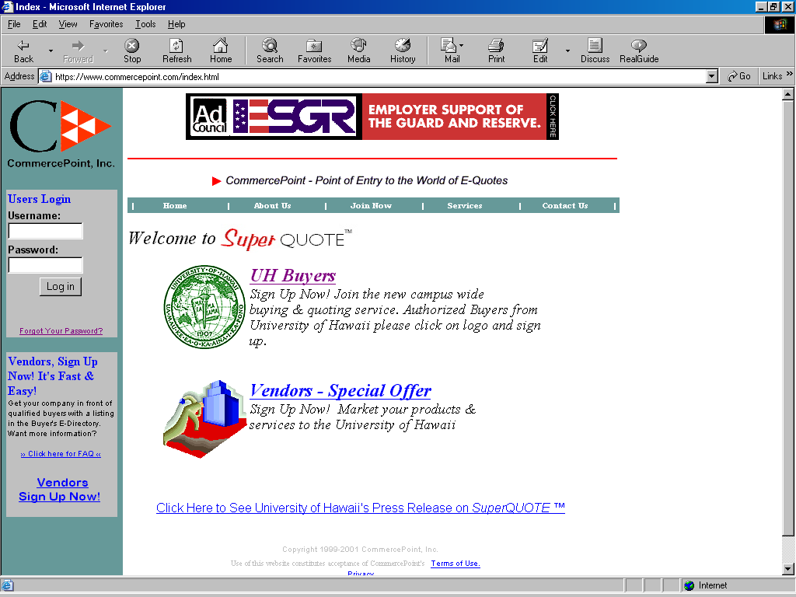

Top of Form
Bottom of Form
Section 8: Bids Via email
The quote MUST be submitted online so if selected it can be awarded.
Section 9: Getting a Draft From the Draft Folder
Step 1: Click on "Draft" (located on the left).
Step 2: Go to the Request Details column and click on the request number (UH-1234) of the request you are looking for.
Step 3: If you want, it is possible to edit your draft and make any necessary changes. When you are ready to submit, click on "Submit Request."

Draft Folder is located here

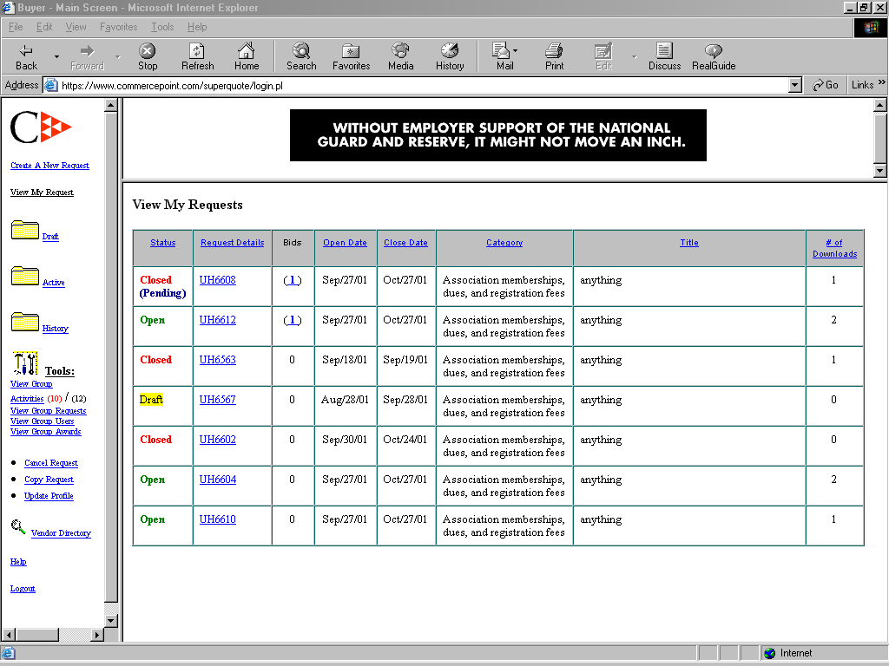
Top of Form
Bottom of Form
Section 10: The Difference between Draft and Active
Draft lists all your saved drafts. Active lists all your open requests.
Section 11: The History Folder
History stores all your closed files.

History Folder is located here

\Top of Form
Bottom of Form
Section 12: Canceling, Addendum or Copying a Request
To cancel a request:
Step 1: Click on "Cancel Request." All your active requests will be listed.
Step 2: Find the request you want to cancel. Go to the far right of the request and click the box that is located in the Cancel Request column. A new screen appears and asks you for a reason for canceling the request. For example: Funding was canceled, thanks for your participation.
Step 3: Type in your answer and click on "OK, go ahead and cancel this request." Your request has know been canceled.
If you change your mind and do not wish to cancel, click on the "clear" or "go back" instead of "OK, go a head and cancel this request." The canceled request will now reside in your History Folder.
To make a change or add an addendum to an Open request:
Step 1: Go to "View My Request" and click on the request number (UH-1234) that you wish to change.
Step 2: Click on "Make Addendum" button on the bottom of the screen.
Step 3: Add the changes, such as Quantity or Item Description and then click on Submit Addendum and it will appear in RED when the vendors look at your request.

If you change your mind or are not sure you can click on Clear to remove the information or you can just click on the X box on the upper right hand corner.
To copy a request:
Step 1: Click on "Copy Request." This will list all of your current files.
Step 2: Find the request you wish to copy and click on "COPY REQUEST" in the far right of the request. A copy of the request will appear with a new Request Number.
Step 3: The request number of the copied request will be noted under "Private Notes." Make sure you change the Open and Close Dates on your new request.

Click here to cancel a request
Click here to copy a request

Top of Form
Bottom of Form
Section 13: Categories not in the Category List
If your category is not listed, send an email to support@commercepoint.com to notify CommercePoint of the category you want added to the Category Listing.

Section 14: Checking on Quotes and Selecting a Winning Vendor
Step 1: Click on "View My Request"

Click here to View your Requests
Bottom of Form
Step 2: Find the request and click on the number under the "Number of Bids" column. Vendors who submitted a bid will be listed. To view a vendor's profile, click on the vendor's name. To view the detail of each vendor's bid, go to the vendor's "Bid Amount & Details." Click on the dollar ($) amount. Go back to the previous screen to select a winning vendor.
Step 3: Find the vendor you want to give the award to and click on the box on the right. There is a default message to the vendors. You may type your own message or leave them blank for no message. You may cancel the award by clicking on "Cancel."
Step 4: When you are ready to send, click on "Award," and the message will be sent.
Section 15: Checking the Status of the Winner Vendor
Click on "View my Request" and find the request and look at the status. If you see "Awarded" the vendor has accepted the award and will be faxing you a signed copy of the RFQ. If the status says, "Closed & Pending" the vendor has not yet responded.
Section 16: The Vendor accepted the Award, what now?
After the vendor accepts the award and faxes you a copy of the signed quote, you will submit a Purchase Order to the vendor. The request will go into History after the vendor accepts the award.
Section 17 : The Vendor Declined the Award
If the vendor declines the award, the status of your request changes from "Closed & Pending" back to Closed. The bid status of the vendor who declined the award will say "Award Declined." You will need to award another vendor's quote. To do this just go to the bids and find the next vendor who's bid is what you want. Then email them asking them if their bid is still valid. Because they would have received an email saying that another vendor was awarded the bid, so you must check and make sure their bid still stands.
Section 18: Awarded the Wrong Vendor and how to fix
By accident you awarded the wrong vendor. An example would be: At first you thought it was the correct model number, but then after you awarded the vendor you realize that it is not the correct model number. And know you want to undo the award. But, the vendor has already accepted the award. This can be done, first contact the vendor and ask them if they will decline the award. After the vendor has agreed to decline the award email CommercePoint.com at support@commercepoint.com. CommercePoint will then move the request back to closed. And at this point you have two options. Either you can cancel the entire request or award the request to another vendor.
Section 19: Viewing a Request your Secretary Submitted
If your secretary used your Username and Password, you can just log on with your Username and Password. And go to "View My Requests" and find the request.
If your secretary uses their own Username and Password, you would have to use their Username and Password. Only Fiscal Officers and Fiscal Officer Assistants can view their own requests and those below them in the Hierarchy Structure.
If your secretary does requests for other buyers and you used your secretary's Username and Password you would be able to see all of the other requests that your secretary made. Therefore, please arrange beforehand which Username and Password your secretary will use if they are going to do the request for you.
Section 20: Changing the Requisitioner Information
The requistioner is the actual buyer. If your secretary uses their own Username and Password for the RFQ, your secretary may change the "Requisitioner" information on the RFQ form by click on the "clear" button (located next to Requisitioner), and enter your name and information. Or your secretary may type in the Special Instructions section, "For any questions on this request, contact (your name) at 956-____."

Enter in the new Requistioner Information here
Top of Form
Bottom of Form
Section 21: Changing the Information on your Profile
Click on "Update Profile" located on left side of screen. You may change the information in your profile at any time. After you have completed the changes, click on "Update" and the changes have taken place and have been saved.

Click here to update your profile

Top of Form
Bottom of Form
Section 22: Using the Vendor Directory
The Vendor Directory is used to help you search for a specific vendor. Click on "Vendor Directory" which is located on the left side of the screen. The new screen says "Vendor Search Criteria." You may use the down arrow in Category to find a vendor in a specific category. You may type in a company name, contact name or a keyword in a Vendor's description, or leave them blank for a listing of all the vendors. Then, click on "Search Vendors."

Click Here to view the Vendor Directory

Top of Form
Bottom of Form
Section 23: Viewing Group Requests and Group Activities
Only the Fiscal Officers and the Assistant Fiscal Officers may view their groups’ requests and the activities of their group's requests
Section 24: Viewing of the Selected Bid
No. This is left up to the buyers. When you award a request you can specify in the message box to other bidding vendors a message like: "Thank you for your participation. The winning bid came in from ABCXYZ Co. at $1999.99."

Section 25: Frequently Asked Questions (FAQ)
If you need help click on Buyer_FAQ.htm, which lists most of the Frequently Asked Questions (FAQ). Need more help? Feel free to contact our Help Desk, Monday - Friday, 9:00am -5:00pm:
CommercePoint, Inc.
1380 Lower Campus Rd, Room #58
Honolulu, HI 96822
Phone: (808)-956-5934
Fax: (808)-956-3110
Email: Support@commercepoint.com

